**SHUBHAM GARG**

**9919103057**

**BATCH: F2**

**QUESTION 1**

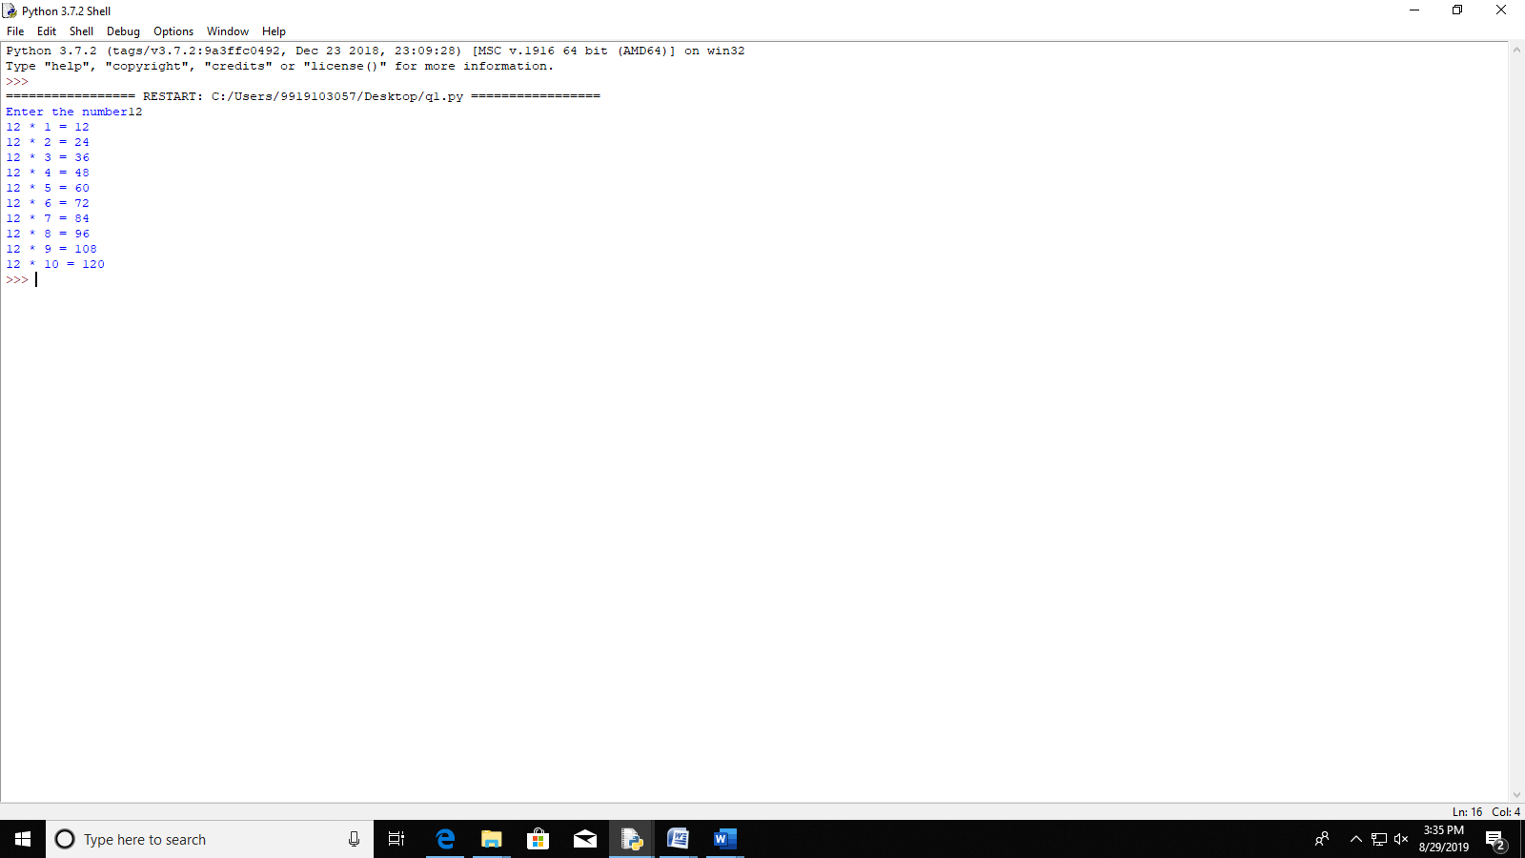

n=int(input("Enter the number"))

i=1

while(i<=10):

print(n,"*",i,"=",n*i)

i+=1

**QUESTION 2**

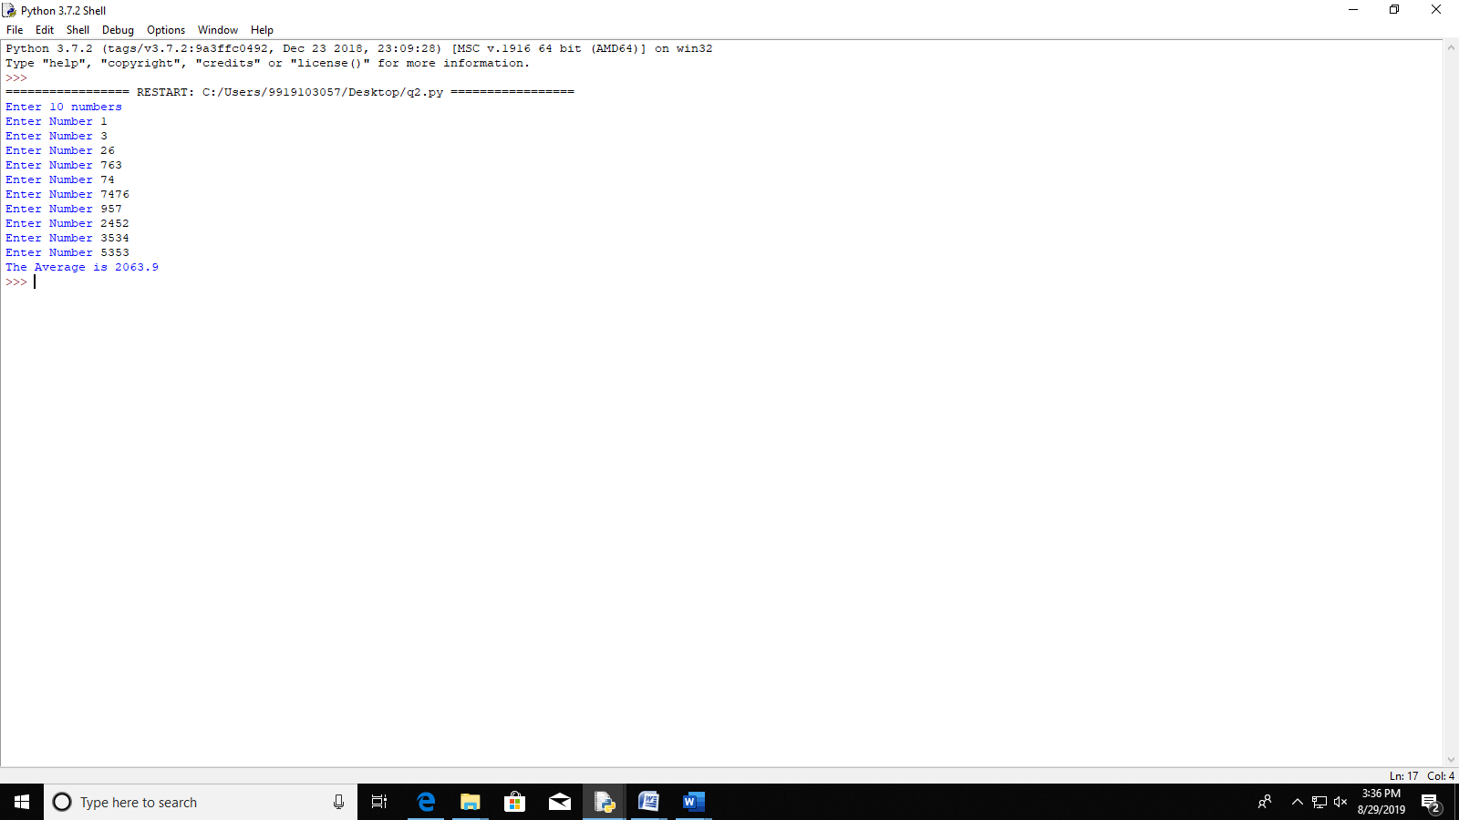

print("Enter 10 numbers")

i=1

avg=0.0

while(i<=10):

n=int(input("Enter Number "))

avg=avg+n

i+=1

print("The Average is",avg/10.0)

**QUESTION 3**

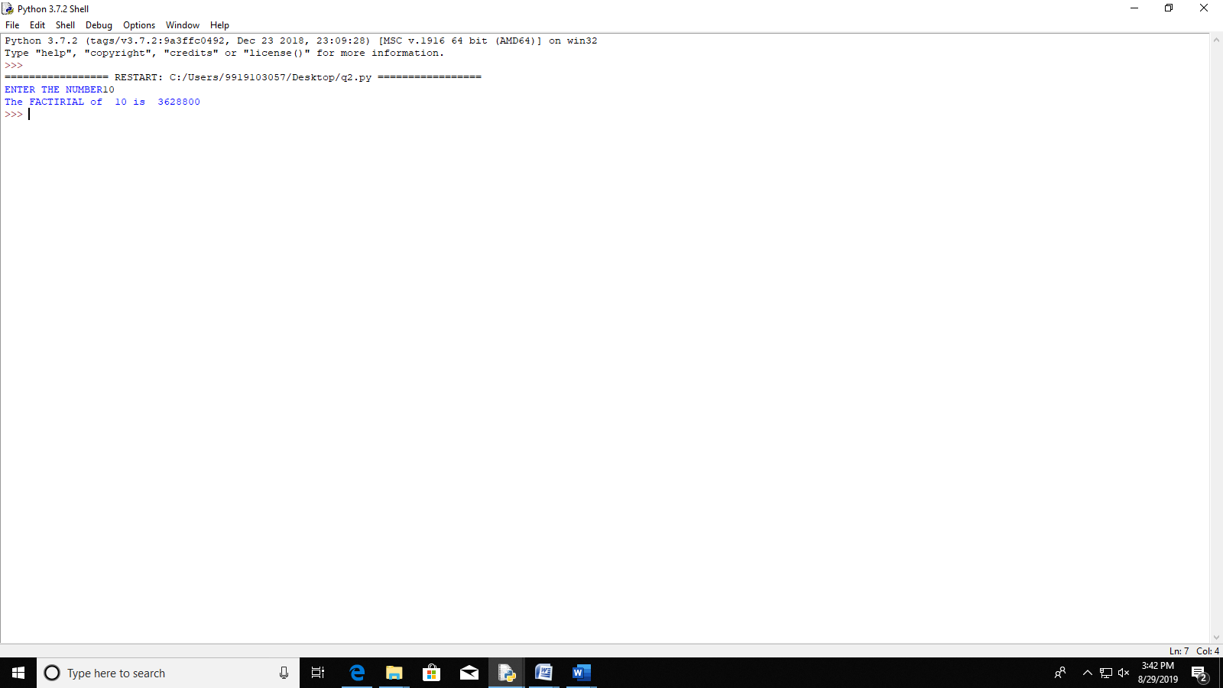

n=int(input("ENTER THE NUMBER"))

i=1

fac=1

while(i<=n):

fac=fac*i

i+=1

print("The FACTIRIAL of ",n,"is ",fac)

QUESTION 4

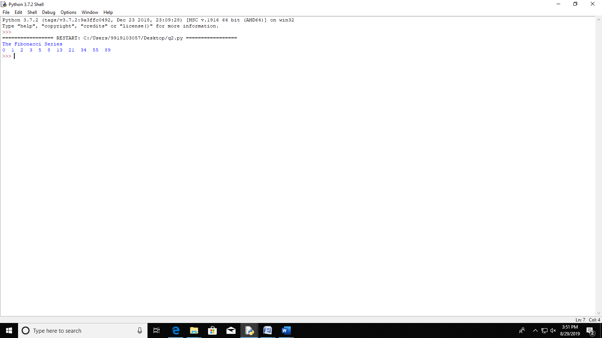

print("The Fibonacci Series")

a=0

b=1

i=1

print(a,end=" ")

while(i<=10):

c=a+b

print(c,end=" ")

a=b

b=c

i+=1

**QUESTION 5**

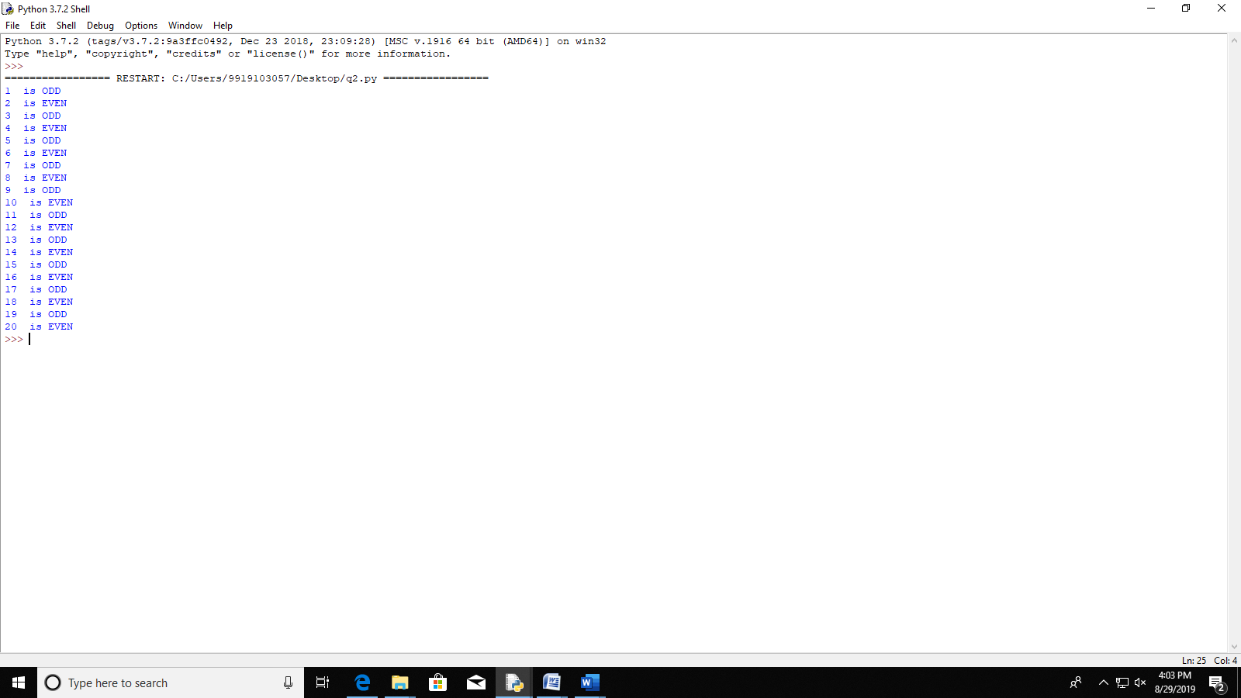

i=1

while(i<=20):

if(i%2==0):

print(i," is EVEN")

else:

print(i," is ODD")

i+=1

**QUESTION 6**

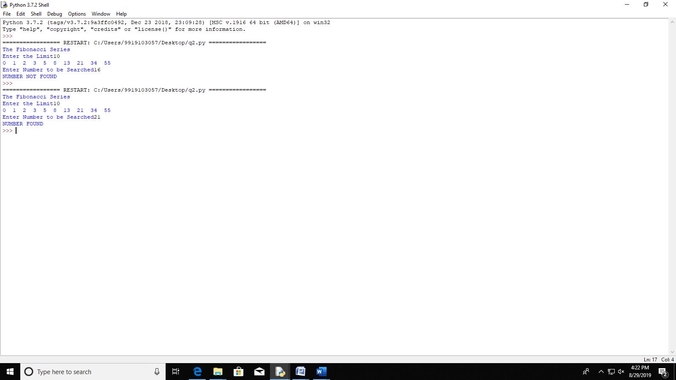

print("The Fibonacci Series")

n=int(input("Enter the Limit"))

d=[]

d.append(0)

a=0

b=1

i=1

print(a,end=" ")

while(i<n):

c=a+b

d.append(c)

print(c,end=" ")

a=b

b=c

i+=1

print()

search=int(input("Enter Number to be Searched"))

i=0

flag=0

while(i<n):

if(d[i]==search):

flag=1

break

i+=1

if(flag==1):

print("NUMBER FOUND")

else:

print("NUMBER NOT FOUND")

**QUESTION 7**

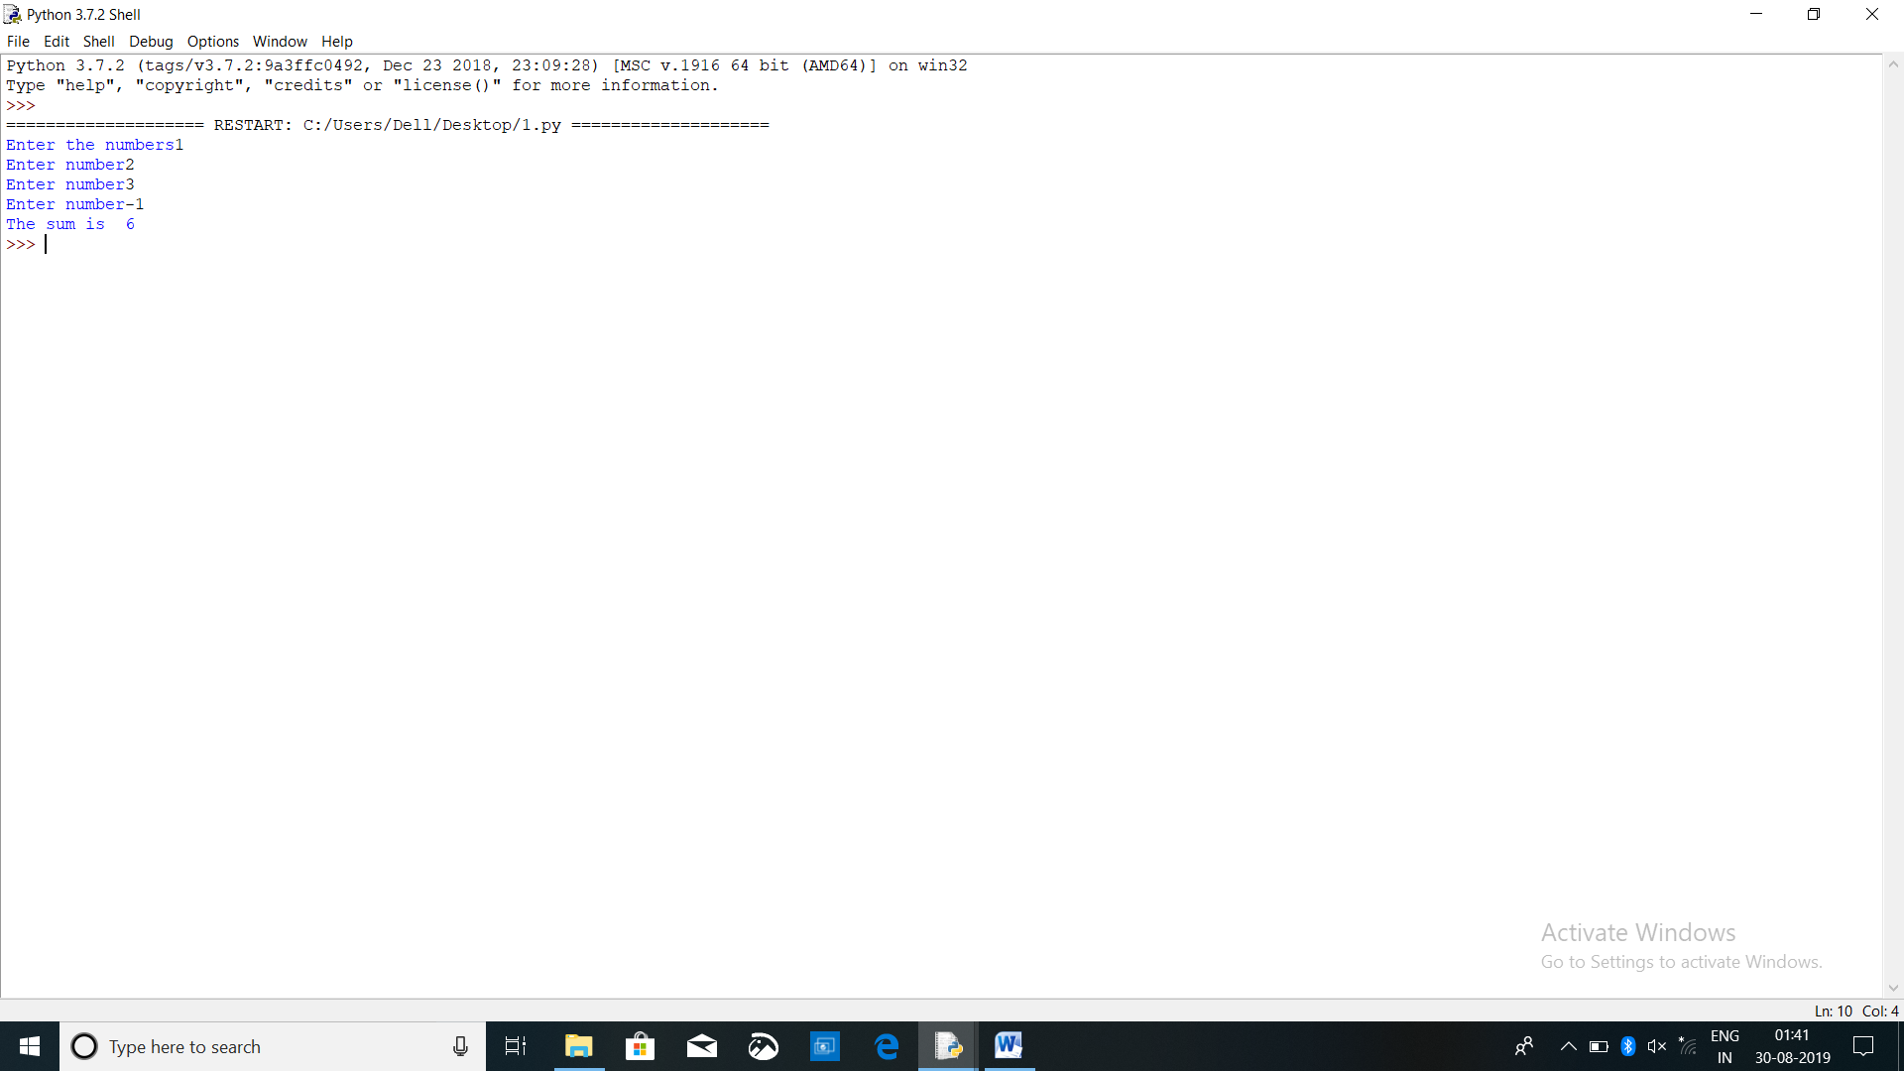

n=int(input("Enter the numbers"))

sum1=0

while(n>0):

sum1=sum1+n

n=int(input("Enter number"))

print("The sum is ",sum1)

**QUESTION 8**

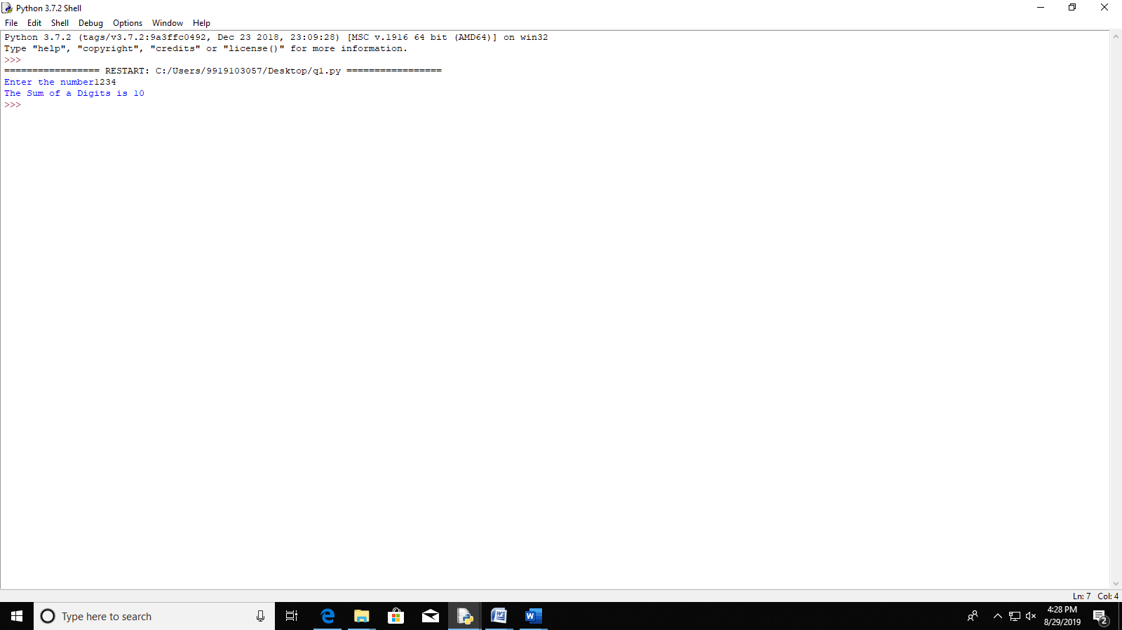

n=int(input("Enter the number"))

sum=0

while(n!=0):

a=n%10

sum=sum+a

n=n//10

print("The Sum of a Digits is",sum)

**QUESTION 9**

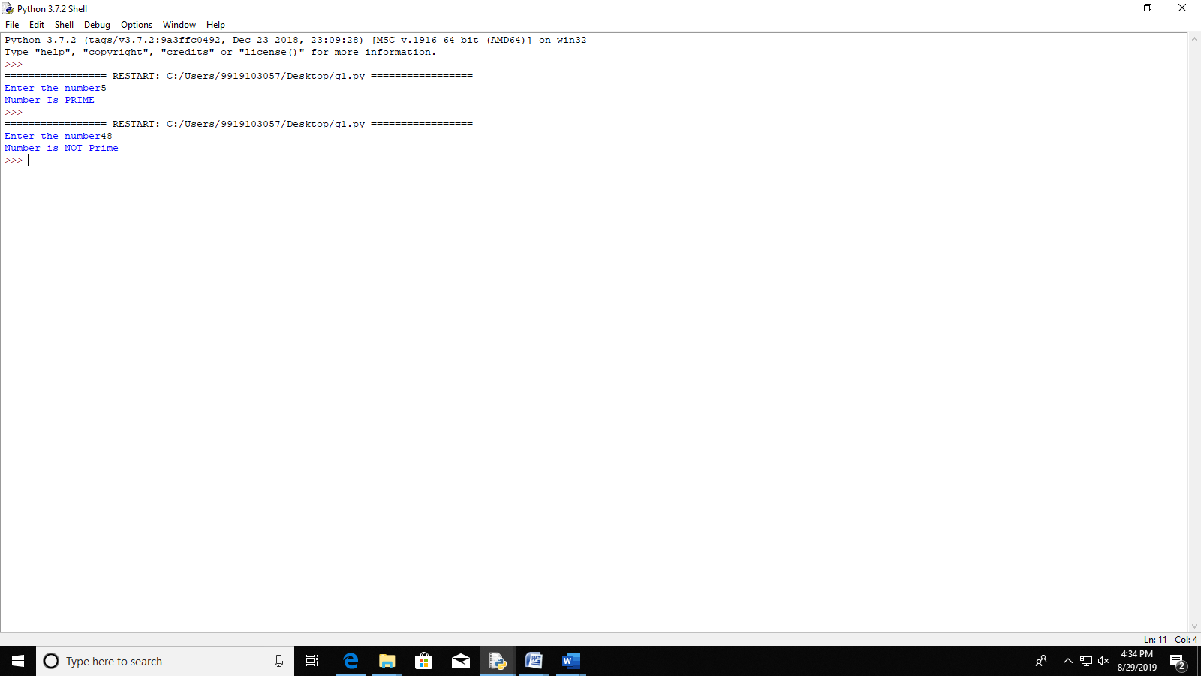

n=int(input("Enter the number"))

i=2

flag=0

while(i<n):

if(n%i==0):

flag=1

break

i+=1

if(flag==1):

print("Number is NOT Prime")

else:

print("Number Is PRIME")

**QUESTION 10**

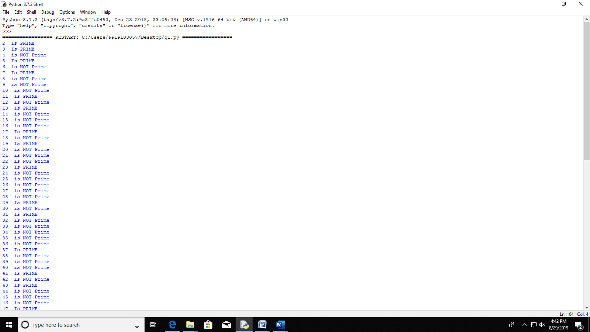

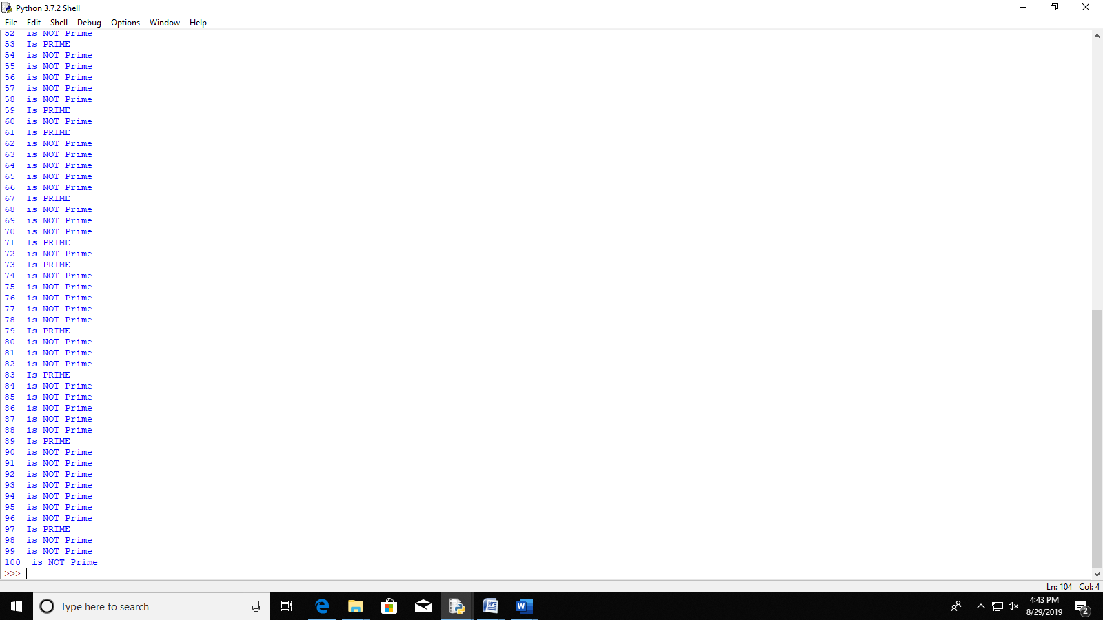

j=2

while(j<=100):

flag=0

i=2

while(i<j):

if(j%i==0):

flag=1

break

i+=1

if(flag==1):

print(j," is NOT Prime")

else:

print(j," Is PRIME")

j+=1

**QUESTION 11**

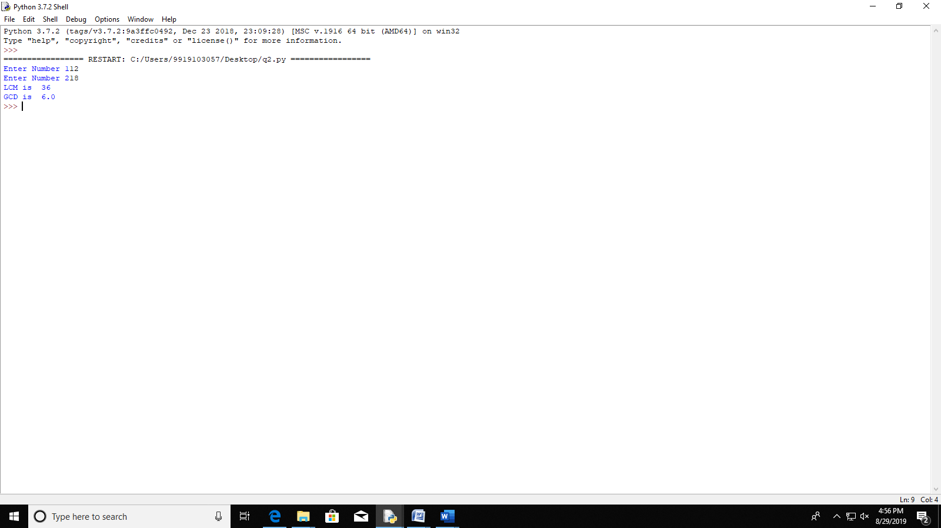

n1=int(input("Enter Number 1"))

n2=int(input("Enter Number 2"))

if(n1>n2):

small=n2

else:

small=n1

i=1

lcm=1

while(i<=small):

if(n1%i==0 and n2%i==0):

lcm=lcm*i

i+=1

gcd=(n1*n2)/lcm

print("LCM is ",lcm)

print("GCD is ",gcd)

**QUESTION 12**

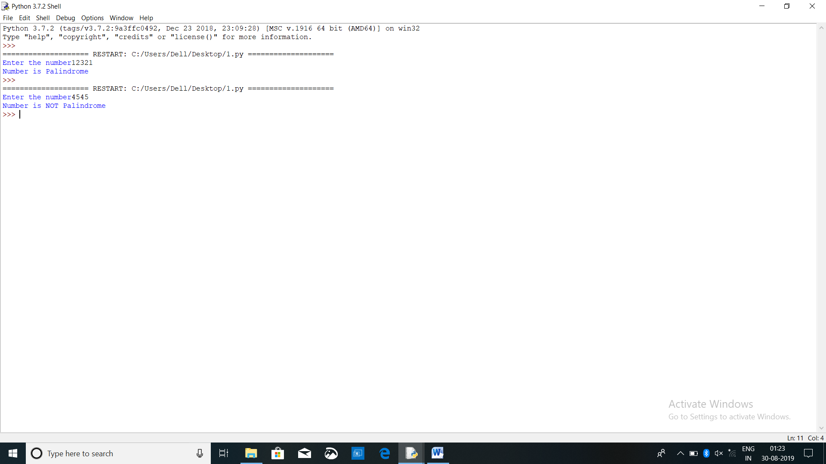

n=int(input("Enter the number"))

dup=n

sum1=0

while(n!=0):

t=n%10

sum1=sum1*10+t

n=n//10

if(dup==sum1):

print("Number is Palindrome")

else:

print("Number is NOT Palindrome")

**-X-X-X-X-X-X-X-X-X-X-X-X-X-X-X-X-X-**